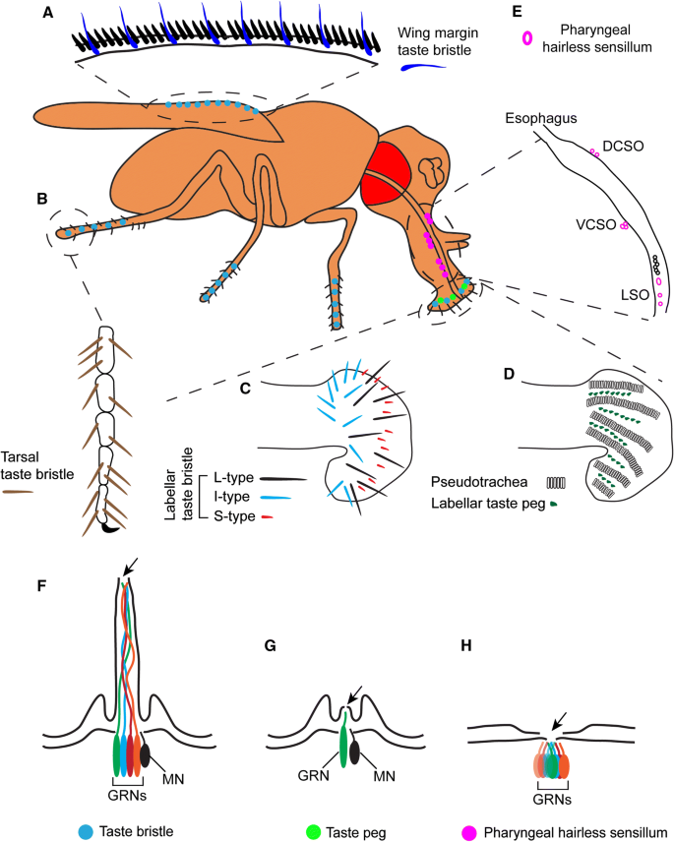
Proboscis Extension Reflex (PER) Assay

The proboscis extension is the reflexive extension of the mouthpart (proboscis) in response to taste stimuli. It is a fundamental feeding behavior that can be stimulated by exposing the antennae, labellar hairs, or tarsi (last segments of the leg) to an appetitive taste stimulus.

While a solution with a low concentration of ethanol is appetitive to fruit flies (serving as an olfactory cue that plant-material fermentation has begun), higher concentrations (>10% EtOH) can be aversive and toxic to fruit flies.
Supplies:  10 flies (5 WT, 5 KO)  Dissecting microscope  Paintbrush  Large petri dish (lid or base)  Clear cyanoacrylate glue  4 mL transfer pipette  6 coverslips  Paper towels  Plastic “fly recovery” box  KimWipes | Solutions:  1 ml DI Water  1 ml 100 mM sucrose solution  1 ml 40% EtOH in 100 mM sucrose solution
Immobilization
- Place fly tubes on ice for 2-3 minutes until flies are immobile.

Note: Keep a close eye on your flies and do not leave them on ice too long! As soon as they’re not moving, you can transfer them.

- Place the bottom of the petri dish upside down on ice. Wipe away condensation before placing flies on the dish.
- Using a brush, very gently isolate one fly onto the petri dish and carefully orient the fly so it is dorsal-side up (Figure E). Be gentle, the flies are very fragile.
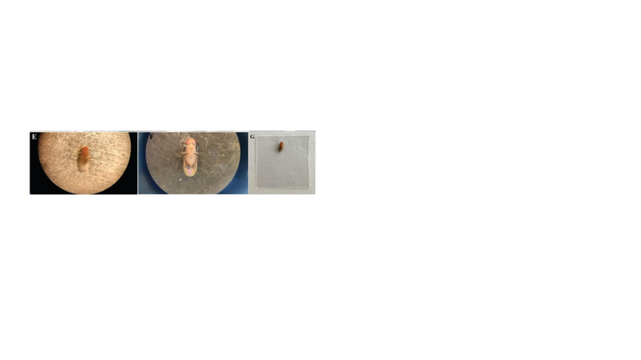
- Prepare a coverslip: using the transfer pipette, place a tiny drop (1 μl, <2 mm in diameter) of glue on a coverslip.
- Gently lower the coverslip onto the dorsal side of the fly, until just submerging the back and wings, immobilizing the fly in the glue (Figures F-G).
Note: Only the back should be submerged in the glue. The head, proboscis, and at least one leg should be exposed - if any one of those parts are submerged, try again with another fly. If you’ve only submerged the wings, try flipping the coverslip over and using forceps to gently lower the back into the glue.
- Place one damp paper towel in the plastic container on your lab bench. Ensure the box is dry. Place the coverslip in the box and close the container to regulate humidity.
- Repeat with the remaining flies.
- Allow the flies to recover for at least 1.5 hours before testing. Complete the other behavioral tests during the recovery period.
Note: Omit flies that do not show movement after 1.5 hours of recovery

Proboscis Extension Reflex Assay
- Choose one of your responsive, immobilized flies with accessible head and legs, and place it under the dissecting microscope. Set up your lighting so you can see the legs and proboscis.
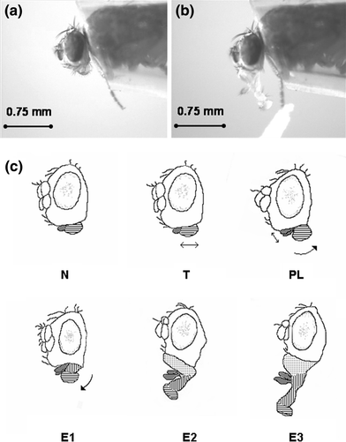
- Dip the corner of a KimWipe in the sucrose solution and gently touch the tarsi with the KimWipe for 3 seconds.
  - Write the PER score in Data Table 1.
Assign a 1 for proboscis extension (see image b). Assign a 0 for no extension (see image a).
  - Wait 3 seconds or until the proboscis retracts.
  - Repeat for 10 trials.
- Repeat using DI water
- Repeat using EtOH/sucrose solution

References
Al-Anzi, B., Tracey, W. D., & Benzer, S. (2006). https://doi.org/10.1016/j.cub.2006.04.002
Chabaud, M.-A., Devaud, J.-M., Pham-Delègue, M.-H., Preat, T., & Kaiser, L. (2006). https://doi.org/10.1007/s00359-006-0160-3
Chen, Y.-C. D., & Dahanukar, A. (2020). https://doi.org/10.1007/s00018-019-03320-0
Devineni, A.V. & Heberlein, U. (2009). https://linkinghub.elsevier.com/retrieve/pii/S0960982209019423
Mandel, S. J., Shoaf, M. L., … & Johnson, E. C. (2018).. https://doi.org/10.3389/fncir.2018.00045
Nakamura et al., (2002). “Defective Proboscis Extension Response (DPR), a Member of the Ig Superfamily Required for the Gustatory Response to Salt”. Journal of Neuroscience. https://doi.org/10.1523/JNEUROSCI.22-09-03463.2002
Trisal, S., VijayRaghavan, K., & Ramaswami, M. (2023). https://doi.org/10.21769/BioProtoc.4891
Data Table 1: PER Responses
 |  | Sucrose | DI Water | 40% EtOH in Sucrose
Wildtype | Trial 1
 | Trial 2
 | Trial 3
 | Trial 4
 | Trial 5
 | Trial 6
 | Trial 7
 | Trial 8
 | Trial 9
 | Trial 10
Knockout | Trial 1
 | Trial 2
 | Trial 3
 | Trial 4
 | Trial 5
 | Trial 6
 | Trial 7
 | Trial 8
 | Trial 9
 | Trial 10

Reflection Question: Identify the positive and negative controls in this experiment. With these controls in mind, are your findings as expected?

